**Team Name:** Noble Team

**Current Leader:** Lucas Scharf

**Members:** Melanie Brown, Marwan Elashry, Viren Kumar, Tanya Malik, Emily Nolan, and Lucas Scharf

**Detailed Work Log 12**

**Melanie Brown:** I met with the team as we establish a time to meet each week and discussed any progress over the break. We discussed what tasks we have left to complete for the project and the timeline for those tasks. We agreed that the webpage and the audio files in windows 11 were left to complete. Since Lucas was able to figure out the audio files, I have been working on my own captured audio file using his process. I haven’t been able to get my audio file working yet, I believe that I may have selected the wrong packets and need to re-select the correct packets again.

**Marwan Elashry:** I met with the team last thursday after our meeting with the SME then we went over what was accomplished last semester and the goal at the time was to convert the file that Lucas had to mp3. We tried doing it but it failed in the last step every time. I tried to put the data into an excel sheet and save it in .sil format but it did not work. After researching I found out the problem might be that FFMPEG is not installed so I installed it and suggested it to lucas and it turned out it was the problem. I was able to convert the first file that was concatenated to an mp3 file.

**Viren Kumar:** Met with *most of* the group to establish a timeline on what we need to get done and what has been completed. I specifically worked on completing the website integration. We are now able to host the website on a kali linux vm and access it on my primary desktop. The steps are as follows:

1. Set Kali Linux network settings to Bridged Adapter
2. Run “sudo service apache2 start”
3. Run “sudo mousepad /var/www/html/index.html”
4. Change the code to the html file you would like to display
5. Run “ip addr” to view the ip that you need to connect to from your host machine
6. Type that ip address into your host machines web browser

Still working on storing the username and password data remotely. I inserted a php script that should make it work, except it didn’t because I believe the file that are supposed to have the data written to are in root access only folders. My plan is to change the access of the folders using chown -R (to change all file permissions within that folder) to allow all users to access it - or more simply just change the location of the folder that hosts the site.

After this, I worked to troubleshoot the issues we were having when turning the transmitted audio packets into the actually mp3 file. I provided Lucas with some ideas on possibly getting it to work, however had no success on that front. Lucas, Mel, Emily, and I had an idea of automating the entire process from start to finish, including collecting the audio packet data and turning it into its mp3 form however wanted to consult you on that first.

**Tanya Malik:** I met with the team and we went over everything that we did in the past. We created future plans to keep us on track for the SAGE competition.

**Emily Nolan:** I met with most of the team and we went over everything that we did over break and reestablished where we were in the project. While we met we set up all the major tasks. I made a small tentative schedule to hopefully keep us on track for the sage competition and give us an idea of what we needed to get done. I also started back up on trying to get the audio data from the wireshark packets but because Lucas is the goat he was able to pull it out. I am hoping he will bless us with his knowledge and give us a demo because I have been unsuccessful. Until then, I think I was using the wrong packets so I am continuing to try to get the audio myself.

**Lucas Scharf:** Met with the team to go over where everyone was and what was done over break. Set up a recurring team meeting schedule.

I was able to pull the audio data from the packets that I captured from the wireshark attached burpsuite. Originally the packets would not concatenate correctly. I was able to solve that by going packet to packet saving each set of data in a single file. Then I concatenated it one by one.

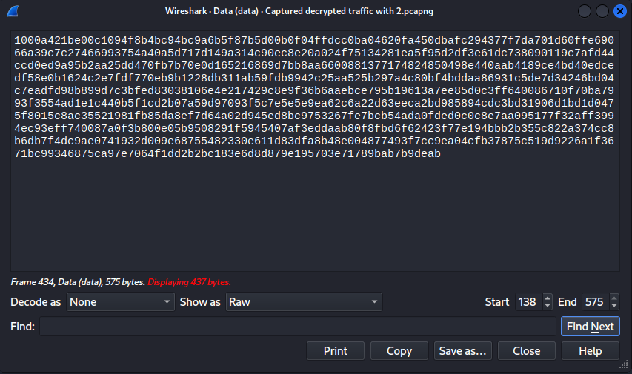

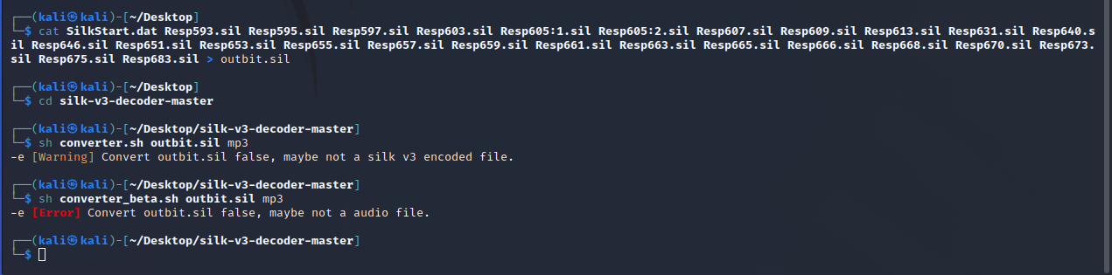

When I converted this data to mp3 it didn't work at first either. After troubleshooting for a long time other team members helped me figure out what seemed to be the issue. FFMPEG was not installed or wasn't up to date.

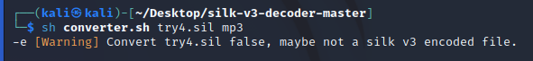

Once updated it did compile the mp3 finally. I was able to play my question to cortana and cortana's response! 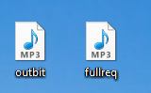This is all on Windows 10. I'm sure it can be replicated with windows 11. I have also started writing a step by step guide that will actually help a person do this from scratch. The previous document left a lot to be desired.